Technical Datasheet of WIN-PiHAT-4DD-2AIAO
1. Overview
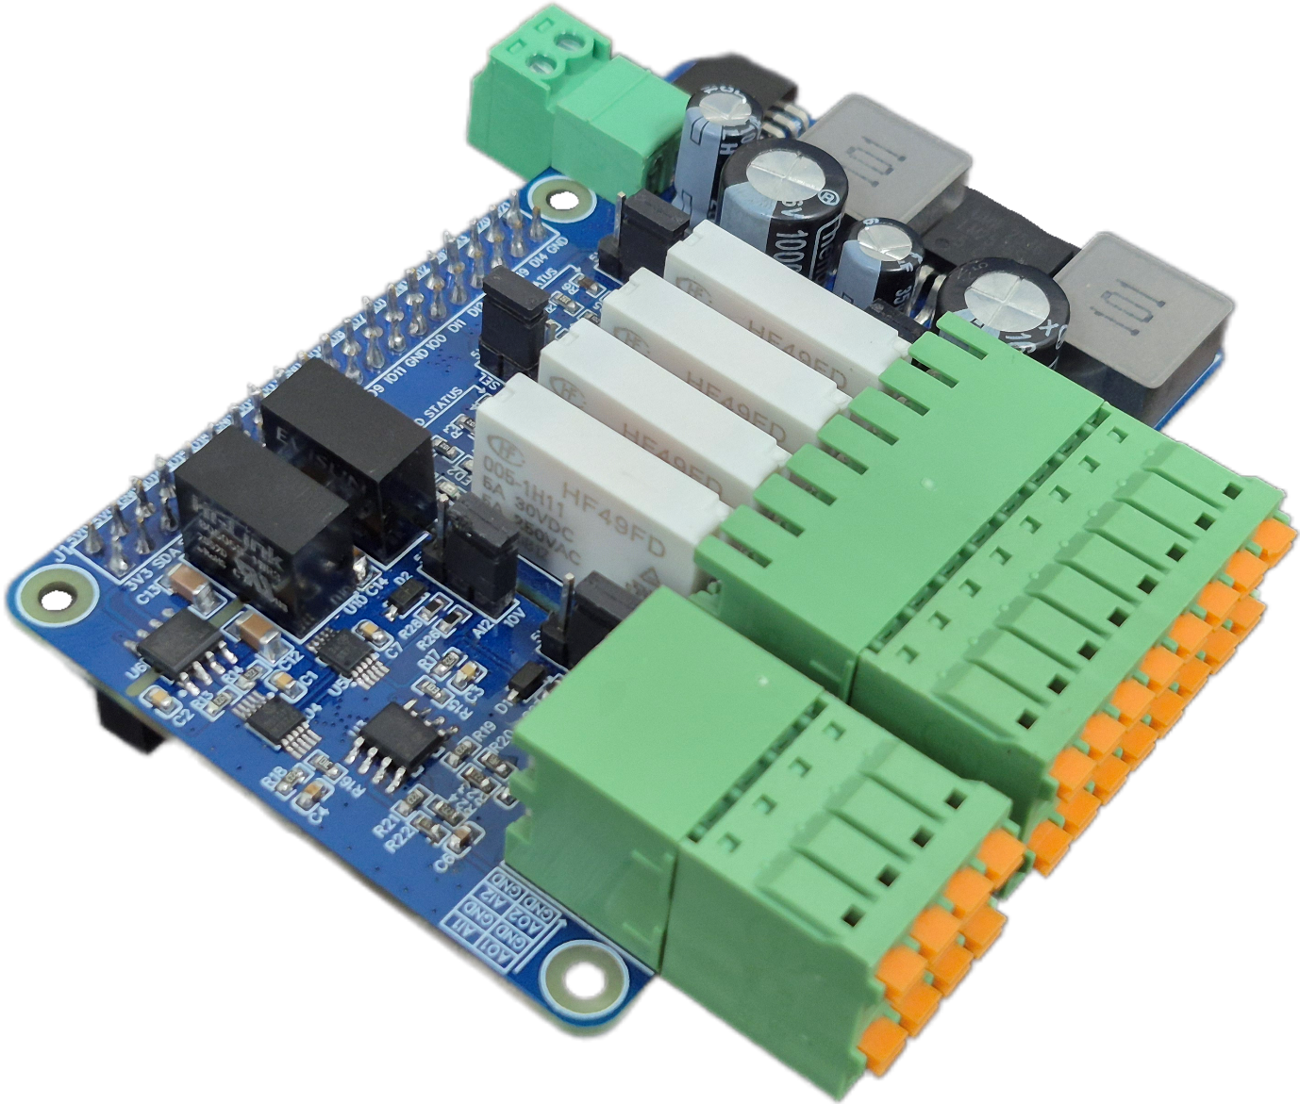
The PiHAT 4DD-2AIAO is a versatile mixed-signal expansion board for Raspberry Pi 4 and CM4, offering comprehensive I/O capabilities for industrial automation and control. It provides precise signal measurement and robust load switching by combining 4 opto-isolated Digital Inputs, 4 relay-driven Digital Outputs, 2 high-resolution Analog Inputs, and 2 Analog Outputs. This ensures seamless data collection and actuation between external field devices and the Pi’s GPIO header for reliable operation in industrial environments.

This PiHAT features a scalable architecture supporting independent analog and digital channels. Its consolidated mixed-signal design allows maximum I/O flexibility while maintaining a compact and reliable solution for embedded sensing, load automation, and precise industrial control applications.
Specifications
Category | 8AI PiHAT
Input Type | Digital: Opto-isolated Digital Inputs  Analog: 12-bit ADC Resolution (Selectable 0-5V, 0-10V, 4-20mA)
Output Type | Digital: Relay-Isolated Digital Outputs (5A @ 250VAC/30VDC)  Analog: 12-bit DAC Resolution (0-10V Range)
Channel Count | 12 Channels Total (4 DI, 4 DO, 2 AI, 2 AO)
Connectors | Terminal Blocks (3.81 mm Pluggable):  • One 2x8-Pin (for all DI & DO channels)  • One 2x4-Pin (for all AI & AO channels)  • One 2-Pin (24V DC; powers PiHAT & Raspberry Pi simultaneously)

General :–

Dimensions 56 mm L x 85 mm W
Power Input Power – 24V DC
Operating Temperature 0 – 60° C (32 ~ 140°F)
Storage Temperature -20 - 70° C (-4 ~ 158°F)
Storage Humidity 5 ~ 95 % RH, non – Condensing
Certifications 

AI (Analog Inputs) :–
Channels 2
ADC Resolution 12-bit
Input Type Single-Ended / Differential (Depending on config)
Voltage Input Range 0 ~ 5V DC, 0 ~ 10V DC
Current Input Range 0 ~ 20mA, 4 ~ 20mA
Input Impedance(V) ≥ 1 MΩ
Input Impedance(I) ~ 250 Ω (Typical for mA drop)
Accuracy ±0.1% to ±0.3% FSR (Full Scale Range)
Sample Rate Programmable (e.g., 128 SPS to 3300 SPS)

AO (Analog Outputs) :-
Channels 2
DAC Resolution 12-bit
Output Type Single-Ended Voltage Output
Voltage Output Range 0 ~ 10V DC
Max Output Current 35 mA (Short-Circuit limit), ~15 mA continuous
Accuracy ±0.1% to ±0.3% FSR (Full Scale Range)
Settling Time 6 µs (Typical)

DI (Digital Inputs) :–
Channels 4
Input Type 12V & 5V with Reference, 80V Absolute Max. @ 50mA
Sense Voltage 3.3 – 12V DC (Depends on the selected type of Input)
Digital Sensing Logic Logic '0' = <1 VDC, Logic '1' = >3.3 VDC
Isolation Optically isolated
Response Time 2 msec, Max 6 msec

DO (Digital Outputs) :-
Channels 4
Output Type Relay-Isolated Digital Outputs (5V SPST-NO Industrial Relay)
Contact Form 1A (SPST-NO)
Contact Material AgNi Alloy
Contact Capacity 5A @ 250VAC, 5A @ 30VDC
Coil Voltage 5VDC
Coil Power 0.12W
Insulation Resistance ≥ 100MΩ
Electrical Life 1x10⁵ operations
Mechanical Life 1x10⁷ operations
Operating Time ≤10 ms (max., at rated voltage)
Release Time ≤05 ms (max., at rated voltage)

Configuration :-
The PiHAT 4DD-2AIAO operates as a comprehensive mixed-signal expansion board, interfacing 4 Digital Inputs, 4 Digital Outputs, 2 Analog Inputs, and 2 Analog Outputs to the Raspberry Pi GPIO header. Data acquisition and load control are managed simultaneously via software running on the Raspberry Pi.

Analog Configuration (AI & AO): The 2 AI and 2 AO channels are managed over a galvanically isolated I2C communication bus utilizing the ISO1540DR isolator. When an external analog signal is applied to an input terminal, the onboard ADS1015 ADC converts it into a precise 12-bit digital value. Conversely, software-generated 12-bit digital commands are sent to the onboard MCP4728 DAC, which immediately converts them into continuous, proportional analog voltages (0-10V) to drive external equipment.

Digital Configuration (DI & DO): The digital channels bypass the I2C bus and interface directly with dedicated Raspberry Pi GPIO pins. The 4 DI channels use optocouplers to safely step-down external signals, allowing your software to read active states as standard logic levels. The 4 DO channels are controlled by driving their assigned GPIO pins HIGH to energize the onboard relays (closing the NO contact) or LOW to de-energize them.

The following are step by step guides for configuration:
- Connect the Board to the Raspberry Pi via header pins
- Connect the Module to 24V DC POWER SUPPLY.

I/O | Signal Name | Pi GPIO | Header Pin Number | Description
2AI & 2AO | SDA | 02 | 03 | Isolated I2C data line for ADS1015 (AI) & MCP4728 (AO)
 | SCL | 03 | 05
4DI | DI1 | 05 | 29 | Direct GPIO monitoring for opto-isolated inputs
 | DI2 | 06 | 31
 | DI3 | 16 | 36
 | DI4 | 26 | 37
4DO | DO1 | 22 | 15 | Direct GPIO control for relay-driven outputs
 | DO2 | 23 | 16
 | DO3 | 24 | 18
 | DO4 | 25 | 22

Wiring Diagram & Terminal Configuration:-
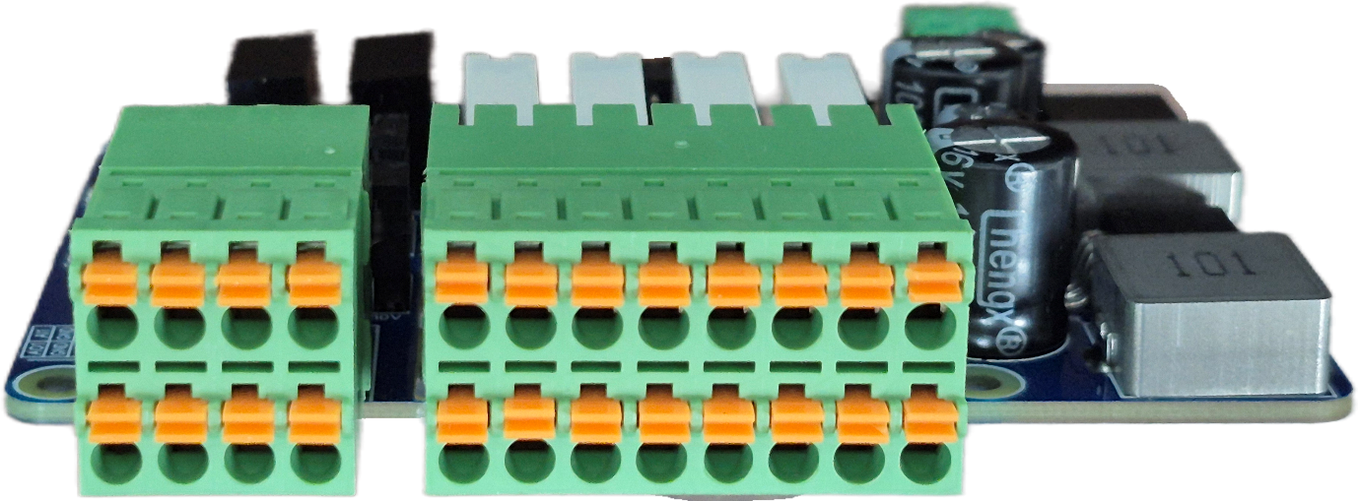
AO1|GND|AO2|GND
AI1|GND|AI2|GND
VIN|VIN|DI1|DI2|DI3|DI4|IN.G|IN.G
C1 |NO1 |C2 |NO2 |C3 |NO3|C4|NO4

Analog Inputs (AI1 – AI2)
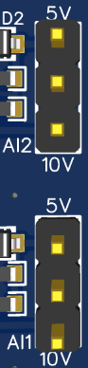
- Terminals: Connect the sensor's positive signal wire to the AIx terminal and the common/ground wire to the corresponding GND terminal.
- Configuration: Each AI channel features a dedicated hardware jumper. Place the jumper on the 5V position to read 0-5V signals, or the 10V position for 0-10V signals. Always ensure this setting strictly matches your sensor's maximum output to prevent data clipping.
Analog Outputs (AO1 – AO2)
- Terminals: Connect the receiving device's signal input to the AOx terminal and its ground reference to the GND terminal. The DAC provides a proportional 0-10V control signal across these pins.
Digital Outputs (DO1 – DO4)
- Terminals: Each relay channel utilizes a Cx (Common) and NOx (Normally Open) terminal pair.
- Wiring: For load switching, connect the load's power supply (Phase/Positive) to Cx, and connect the load itself to NOx. When the software drives the GPIO high, the relay energizes, closing the internal circuit between Cx and NOx.

Digital Inputs (DI1 – DI4)
- Terminals: Connect the switching signals to the DIx terminals. Depending on your switching logic, DI signals are measured with respect to either VIN (Voltage Input Reference) or IN.G (Input Ground).
- Configuration: Use the onboard DI_PULL jumper to set the pull state (High/Low) for the optocouplers.
- External Power Warning: If your application uses an external reference voltage source to drive the digital inputs, you must completely remove the associated internal jumpers (VCC_SEL and IN.G) to ensure safe electrical isolation.
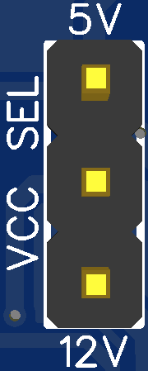
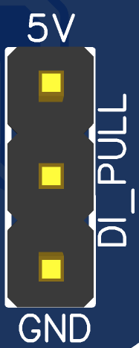


Sample Code & Examples :-
Access the official Python example scripts for 4DI, 4DO, 2AI, and 2AO control and testing from our repository here:

- WIN-PiHAT-4DD-2AIAO

Hardware Interface & Connector Layout:

40 pin GPIO Headers
24V DC SPLY
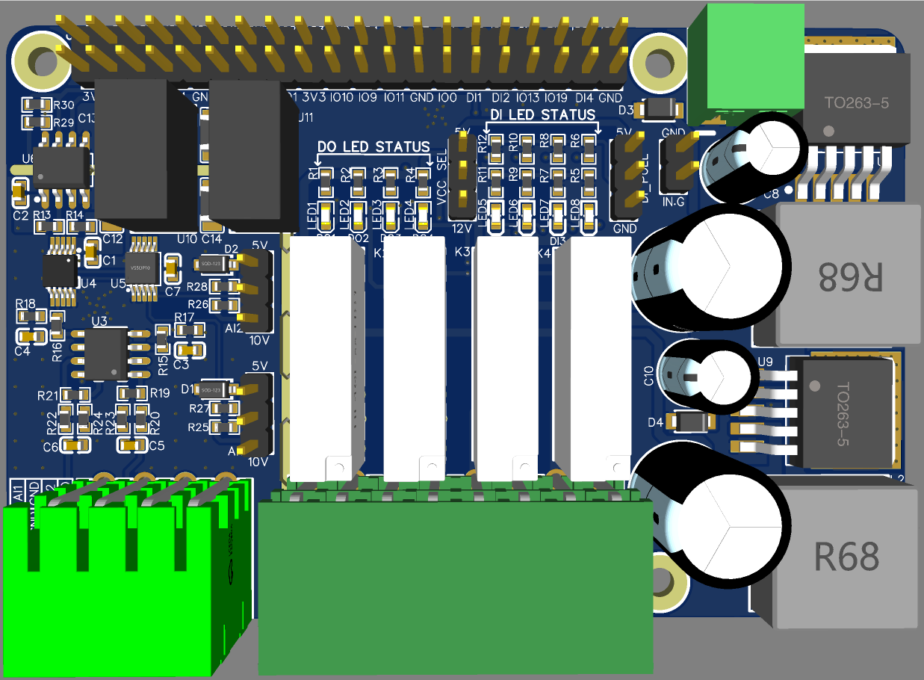
2
1
40
39
DI PULL-UP & PULL- DOWN

VIN Voltage Reference

0-5/0-10V
JUMPER

C1 | NO1 | C2 | NO2 | C3 | NO3 | C4 | NO4
VIN | VIN | DI1 | DI2 | DI3 | DI4 | IN.G | IN.G
AI1 | GND | AI2 | GND
AO1 | GND | AO2 | GND
VIN Voltage Reference

Contact us: -
Augmatic Technologies Pvt. Ltd.,
Plot no 6, Shah Industrial Estate II,
Kotambi,
Vadodara – 391510.
Email – Sales@wittelb.com
Support: support@wittelb.raiseaticket.com / +91 94038 92805

